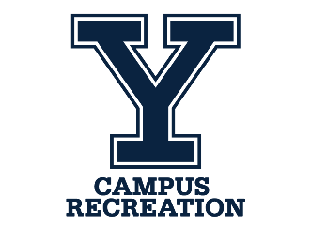 | Outdoor Recreation  Summer Internship  Position Description

Position Focus
A paid summer outdoor recreation internship at the Yale Outdoor Education Center may include lifeguarding and/or supervising a fleet of rowboats and paddlecraft at a private, 2,000-acre outdoor recreation center on a pristine, mile-long lake in East Lyme, Connecticut. The internship may be a combination of all job descriptions found on the YOEC’s employment page, depending on the applicant’s desires and skillset, as well as program needs. We can customize additional learning projects.

Principal Responsibilities
- May lifeguard adults and children from a floating H-shaped dock.
- Provide water safety supervision and instruction for customers.
- Supervise rowboats, kayaks, paddleboards, and canoes from a beach and boat dock.
- Make paddlecraft rescues or assists with a rescue board, staff kayak, or motorboat.
- Perform light waterfront and facility maintenance work.
- Lead day and/or evening recreational activities for adults and children.
- Monitor waterfront safety, crowd control, and customer behavior for swimming/boating.
- Internship activities can be tailored to meet individual, programmatic, and facility needs.
- Provide exceptional customer service in a unique and safe outdoor recreation environment.
- Have a desire to learn from an experienced waterfront staff and facility director.

Qualifications, Hours, Compensation, and to Apply
- May need to hold (or obtain) Lifesaving certification with the Waterfront component.
- Current Red Cross First-Aid, CPR & AED certification for adults and children.
- Basic boating/paddlecraft knowledge preferred.
- Connecticut Safe Boating course certification preferred (or can obtain).
- Reliable, trustworthy, and punctual. Mature and responsible behavior.
- Ability to resolve customer needs and issues on the waterfront and on the grounds.
- Successful completion of a Yale background check.
- Available flex hours: Weekends, holidays, and weekdays, range from 9:30 am to 10:00 pm.
- Free housing in a rustic lakeside staff cabin.
- Preferred job period: Mid-June through Labor Day.
- Payrate $19.00/hour.
- Includes free family membership, if desired.
- To inquire or apply, send a cover letter and resume to tom.migdalski@yale.edu

